**Calculating Family Expenses Using ServiceNow**

**Team Id: NM2025TMID15448**

**Team Members: 4**

**Team Leader: MUGILAN S**

**Team Member 1: ARJUN V**

**Team Member 2: THARANESWAR R**

# Team Member 3: IYYAPPAN K

**Problem Statement:**

Families spend money every day on food, bills, travel, and other needs. Writing down expenses in notebooks is not easy to manage, and mistakes can happen. There is no single system to record, organize, and track family expenses.

**Objective:**

* To create an application in ServiceNow to record and calculate family expenses.
* To create tables for members, categories, and daily expenses.
* To link all expenses with family members using relationships.
* To add business rules and approvals for better control.

**Skills:**

* ServiceNow basics
* Tables and Relationships
* Update Sets
* Business Rules
* Flow Designer

**TASK INITIATION**

**Milestone 1 : Setting Up ServiceNow Instance**

# Activity 1: Create Instance

1. Go to [developer.servicenow.com.](https://developer.servicenow.com/)
2. Sign up for a free developer account.
3. After logging in, click **Personal Developer Instance**.
4. Click **Request Instance** to create your own ServiceNow space.
5. Fill in the form and submit it.
6. You will get an email with your instance link, username, and password.
7. Log in with those details.
8. Now your ServiceNow instance is ready to use.

**Milestone 2 : Creation of New Update Set**

# Activity 1: Create Update Set

1. Go to **All** in ServiceNow.
2. In the filter search box, type **Local Update Sets** and click on it.
3. Click on **New**.

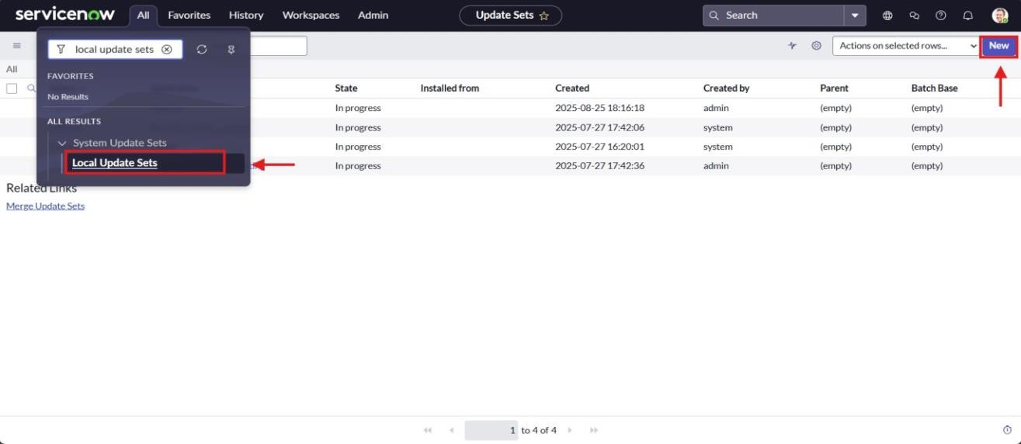

1. Enter the details:

• **Name**: Family Expenses

1. Click on **Submit and Make Current**.

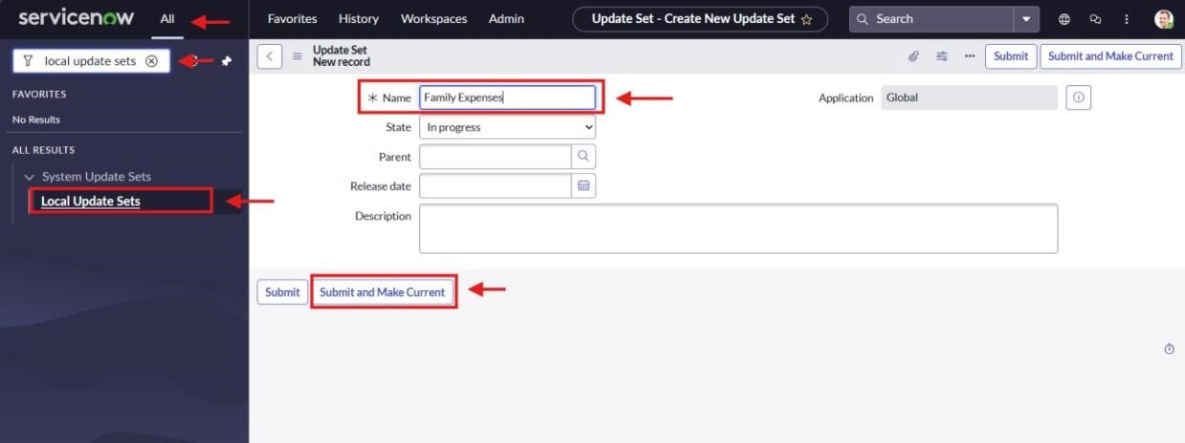

**Milestone 3 : Creation of Table**

# Activity 1: Create Family Expenses Table

1. In ServiceNow, go to **All**.
2. In the filter search box, type **Tables**.
3. Click on **Tables** under *System Definition*.
4. Click on **New**.

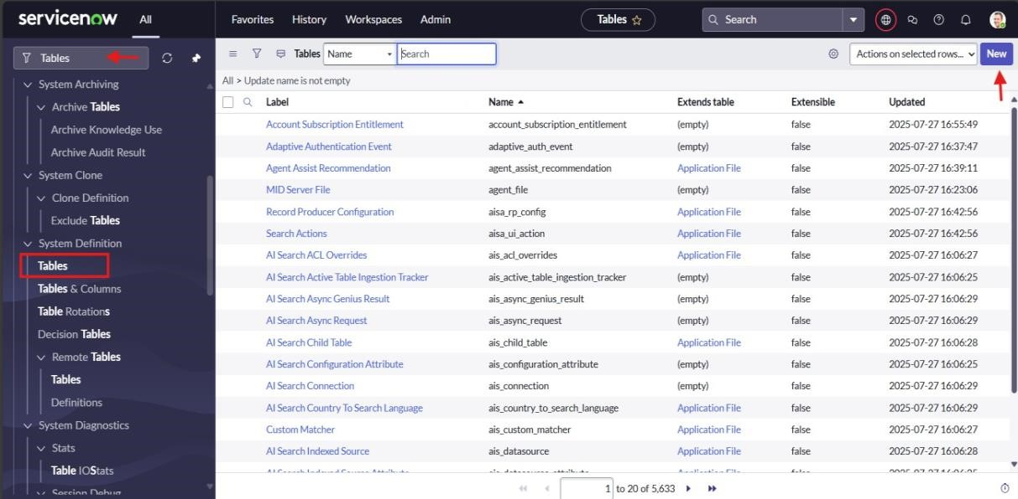

1. Enter the details:
   * **Label**: Family Expenses
   * **Name**: (Auto-populated)
   * **New menu name**: Family Expenditure
2. Go to the header, right-click, and select **Save**.

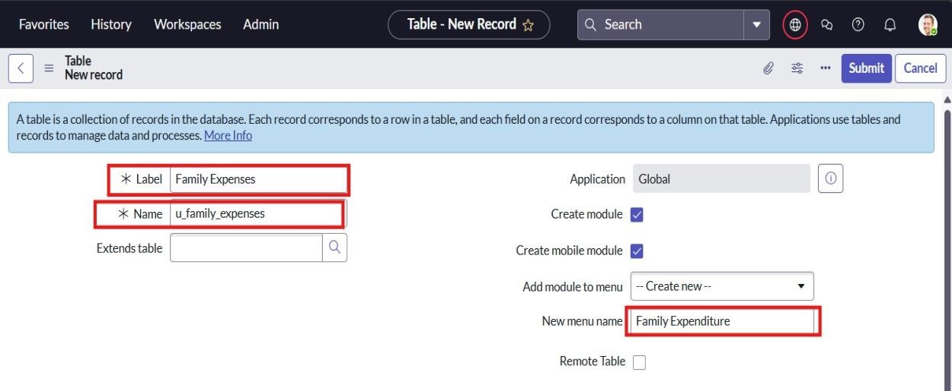

# Activity 2: Create Table

1. In the **Family Expenses** table, go to the **Columns** section.
2. Double-click near **Insert a new row**.
3. Enter the details:
   * **Column label**: Number
   * **Type**: String
   * Again double-click.
   * **Column label**: Date
   * **Type**: Date
   * Again double-click.
   * **Column label**: Amount
   * **Type**: Integer
   * Again double-click.
   * **Column label**: Expense Details
   * **Type**: String
   * **Max length**: 800
4. Go to the header, right-click, and select **Save**.

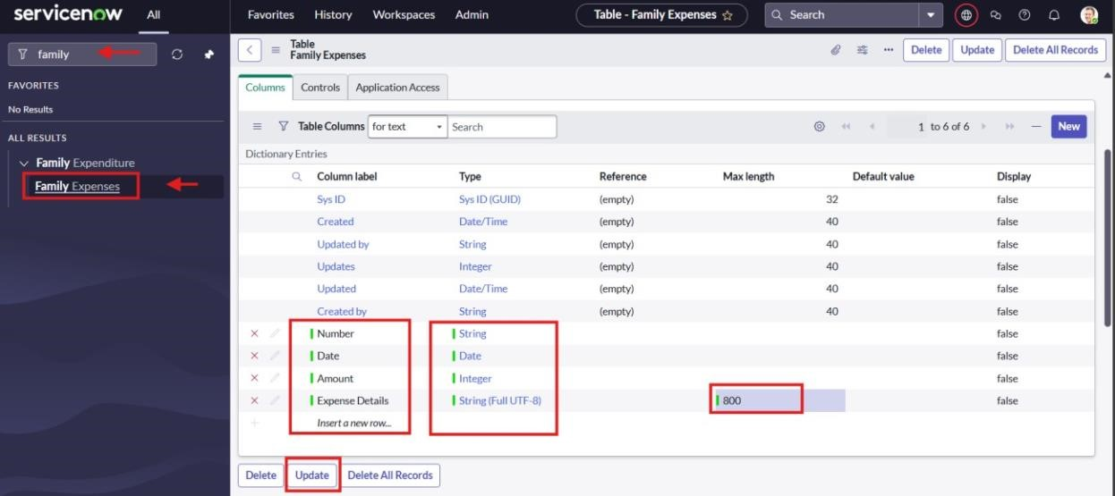

# Activity 3: Configure Auto Number for Family Expenses Table

1. Open the **Family Expenses** table.
2. Double-click the **Number** field/column.
3. Scroll down and switch to **Advanced view**.
4. In **Default Value**:
   * Tick **Use dynamic default**.
   * Select **Get Next Padded Number**.
5. Click **Update**.

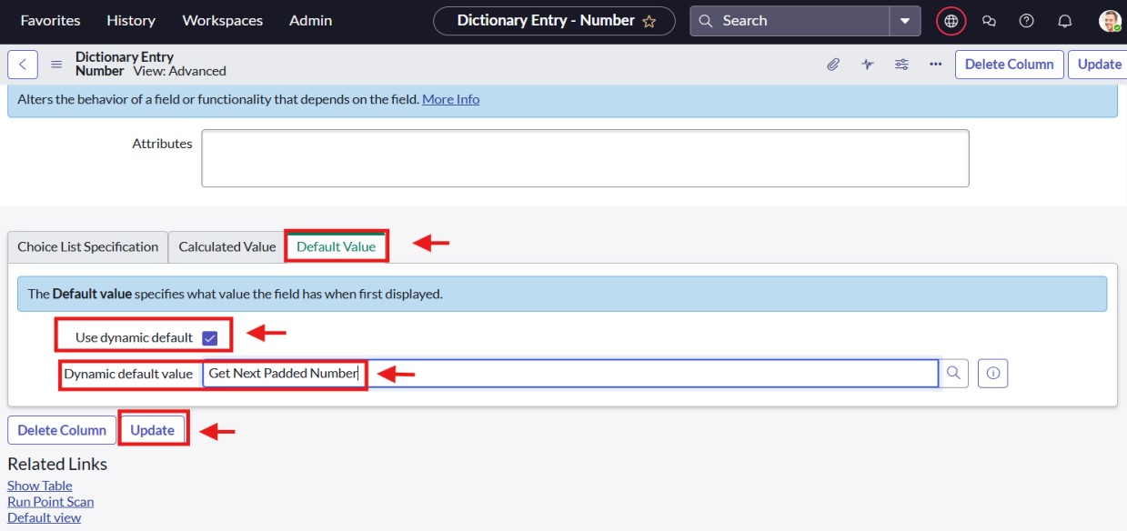

# Activity 4: Create Number Maintenance

1. In ServiceNow, go to **All**.
2. In the search box, type **Number Maintenance** and select it.
3. Click **New**.
4. Enter the details:
   * **Table**: Family Expenses
   * **Prefix**: MFE
5. Click **Submit**.

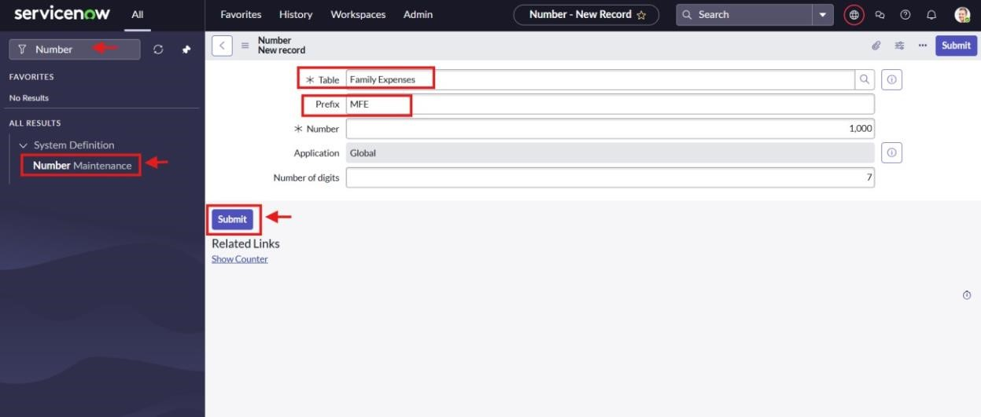

# Activity 5: Configure the Form

1. In ServiceNow, go to **All** and search for **Family Expenses**.
2. Open **Family Expenses** and click on **New**.
3. In the header, right-click → select **Configure → Form Design**.

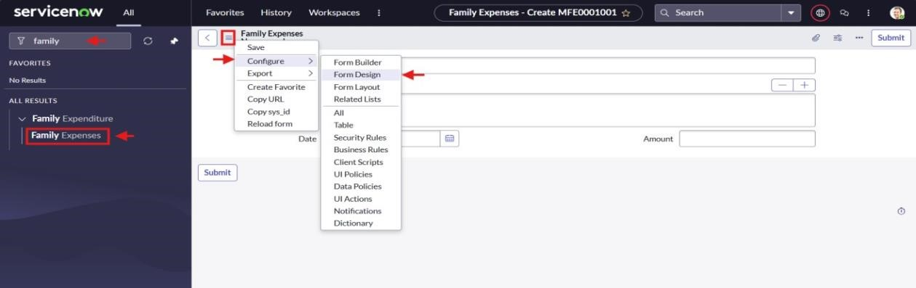

1. Arrange or drag & drop fields as needed.
2. For **Number** field: set it to **Read-Only** (using the gear icon).
3. For **Date** and **Amount** fields: set them as **Mandatory** (using the gear icon).
4. Click **Save**.

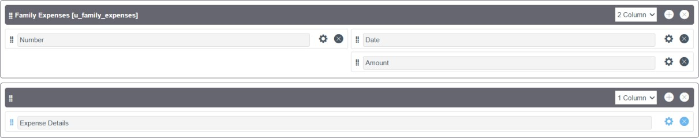

# Milestone 4 : Creation of Daily Expenses Table Activity 1: Create Daily Expenses Table

1. In ServiceNow, go to **All**.
2. In the search bar, type **Tables** and click on it.
3. Click on **New**.
4. Enter the details:
   * **Label**: Daily Expenses
   * **Name**: (Auto-populated)
   * **Add Module to menu**: Family Expenditure
5. In the header, right-click and click **Save**.

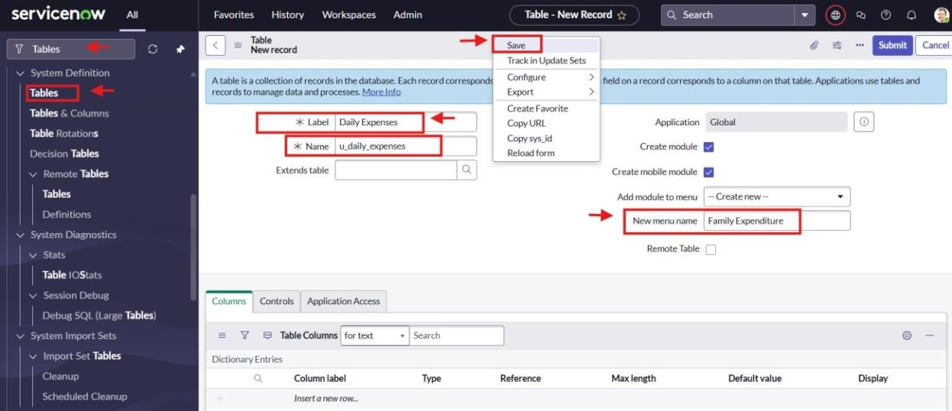

# Activity 2: Add Columns (Fields) to Daily Expenses Table

1. In the **Daily Expenses** table, go to the **Columns** section.
2. Double-click on **Insert a new row** to add fields.
3. Add the following columns one by one:
   * **Column label**: Number → **Type**: String
   * **Column label**: Date → **Type**: Date
   * **Column label**: Expense → **Type**: Integer
   * **Column label**: Family Member Name → **Type**: Reference (Max length: 800) **Reference:** User there show sys_user
   * **Column label**: Comments → **Type**: String (Max length: 800)
4. After adding all columns, go to the header, right-click, and click **Save**.

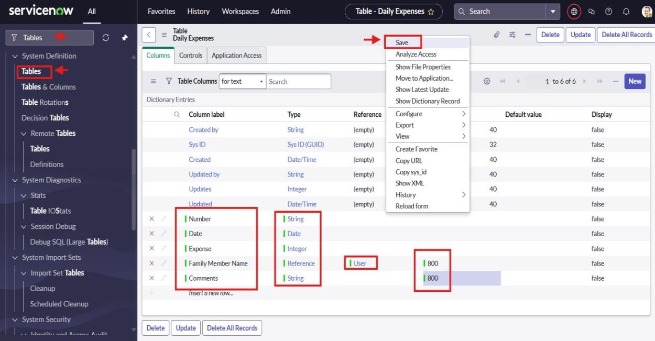

# Activity 3: Make Number Field Auto-Generate

1. In the **Daily Expenses** table, double-click on the **Number** field.
2. Scroll down and switch to **Advanced view**.
3. In **Default Value**:
   * Tick **Use dynamic default**.
   * Select **Get Next Padded Number**.
4. Click **Update**.

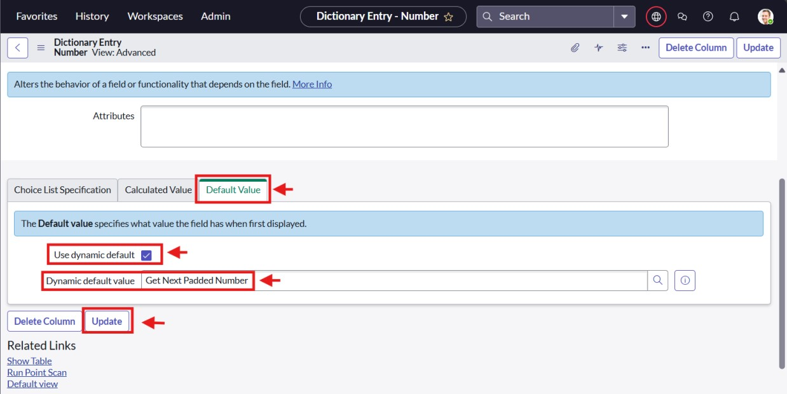

# Activity 4: Number Maintenance

1. In ServiceNow, go to **All**.
2. Search for **Number Maintenance** and open it.
3. Click on **New**.
4. Enter the details:

• **Table**: Daily Expenses • **Prefix**: DFE (Daily Expenses)

1. Click **Submit**.

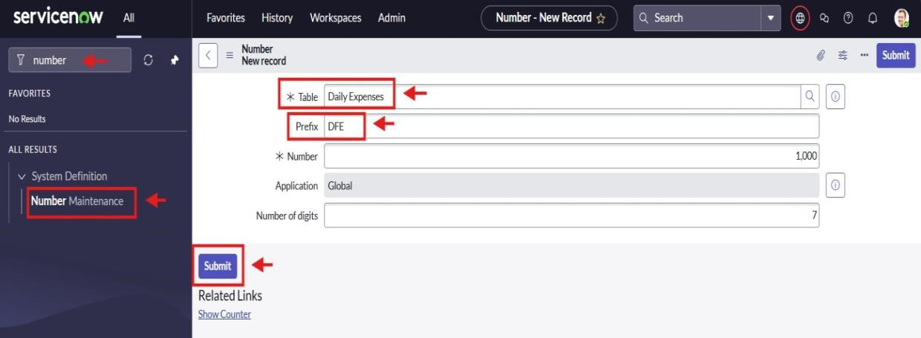

# Activity 5: Configure the Form

1. In ServiceNow, go to **All** and search for **Daily Expenses**.
2. Open **Daily Expenses** and click on **New**.
3. In the header, right-click → choose **Configure → Form Design**.

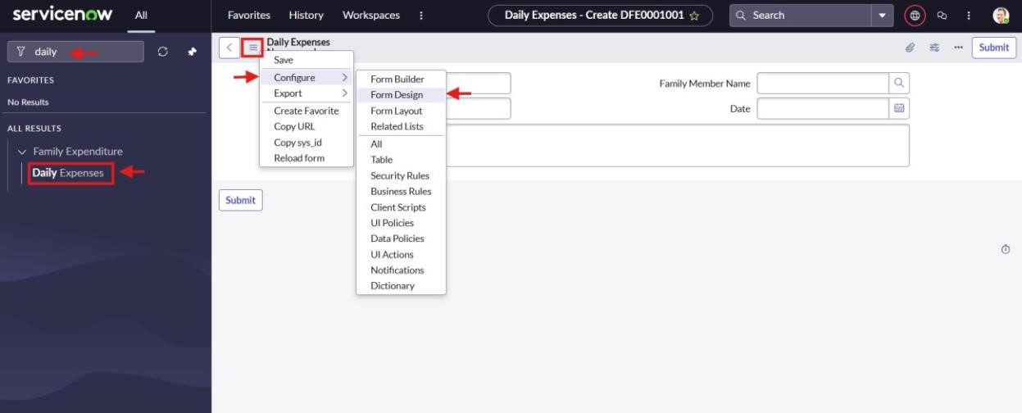

1. Arrange or drag & drop the fields as needed.
2. For the **Number** field: set it to **Read-Only** (using the gear icon).
3. For **Date** and **Family Member Name** fields: set them as **Mandatory** (using the gear icon).
4. Click **Save**.

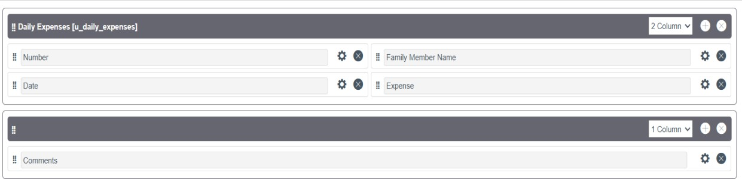

**Milestone 5: Creation of Relationship between Tables**

**Activity 1: Link Family Expenses and Daily Expenses Tables**

1. In ServiceNow, go to **All**.
2. In the search box, type **Relationships** and open it.
3. Click on **New**.
4. Enter the details:
   * **Name**: Daily Expenses
   * **Applies to table**: Family Expenses
   * **Related table**: Daily Expenses
5. Click **Save**.

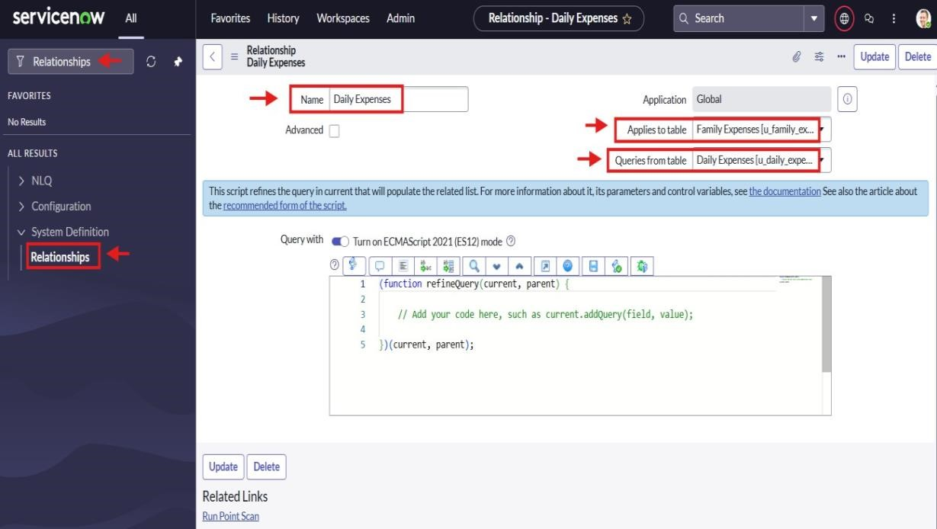

**Milestone 6 : Configuring Related List on Family Expenses**

# Activity 1: Add Daily Expenses as Related List

1. In ServiceNow, go to **All** and search for **Family Expenses**.
2. Open **Family Expenses** and click on **New**.
3. In the header, right-click → choose **Configure → Related Lists**.

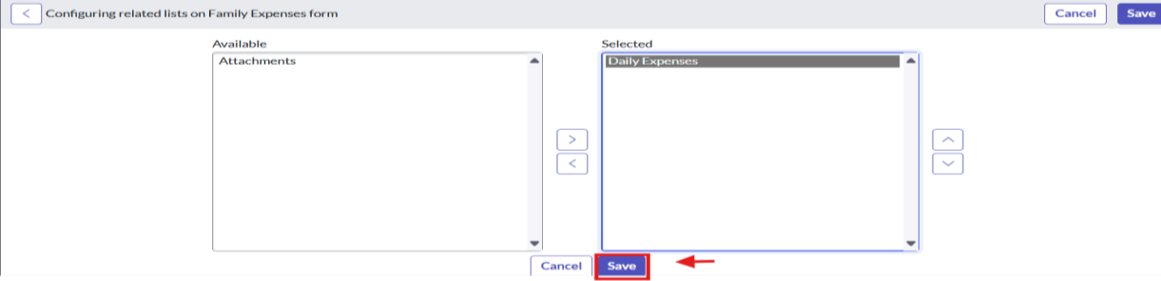

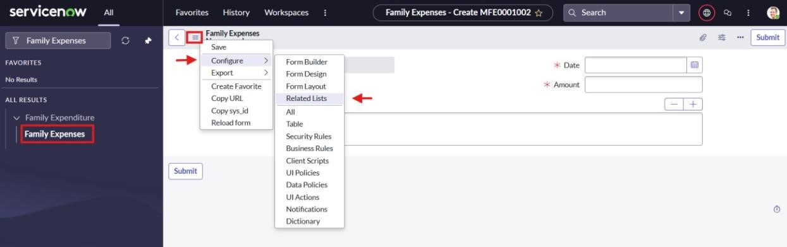

1. From the options, add **Daily Expenses** to the selected area.
2. Click **Save**.

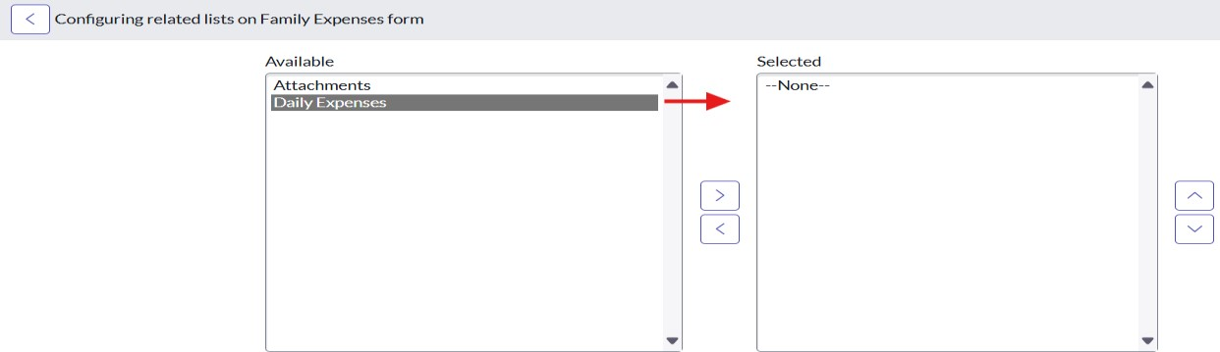

**Milestone 7: Creation of Business Rules**

# Activity 1: Add Business Rule for Family Expenses

1. In ServiceNow, go to **All**.
2. In the search bar, type **Business Rules** and select it under *System Definition*.
3. Click on **New**.
4. Enter the details:
   * **Name:** Family Expenses BR
   * **Table:** Daily Expenses
   * Check **Advanced**.

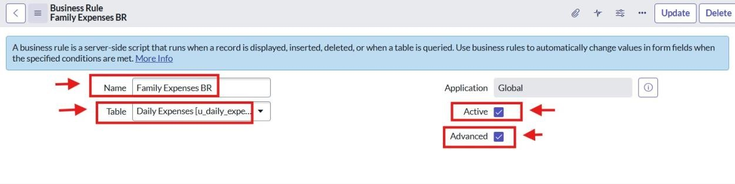

1. Under When to run, check Insert and Update.

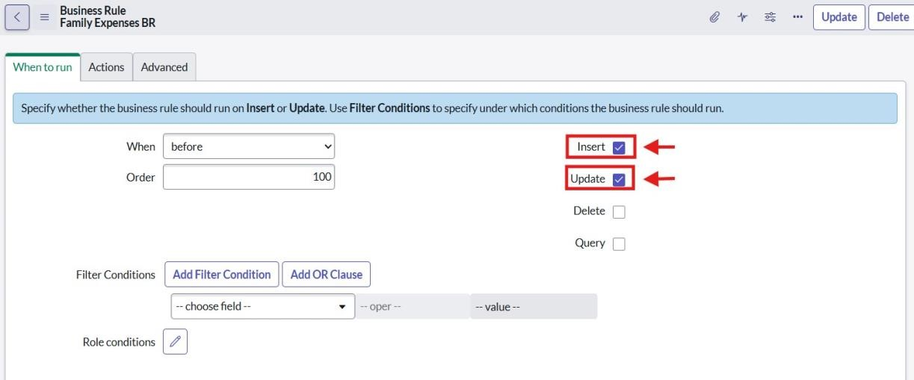

1. In the Advanced section, paste the following script:

(function executeRule(current, previous /*null when async*/) {

var FamilyExpenses = new GlideRecord('u_family_expenses');

FamilyExpenses.addQuery('u_date', current.u_date); FamilyExpenses.query();

if (FamilyExpenses.next()) {

FamilyExpenses.u_amount += current.u_expense;

FamilyExpenses.u_expense_details += " > " + current.u_comments + ": Rs." + current.u_expense + "/-";

FamilyExpenses.update();

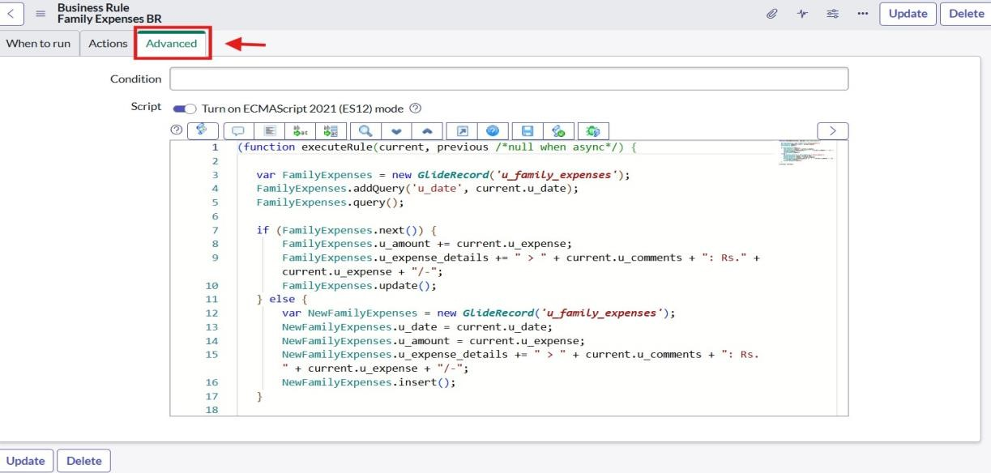} else { var NewFamilyExpenses = new GlideRecord('u_family_expenses');

NewFamilyExpenses.u_date = current.u_date;

NewFamilyExpenses.u_amount = current.u_expense;

NewFamilyExpenses.u_expense_details += " > " + current.u_comments + ": Rs." + current.u_expense + "/-";

NewFamilyExpenses.insert();

}

})(current, previous);

7. Go to the header, right-click, and click Save.

# Milestone 8: Flow

## Activity 1: Update Daily Expenses Relationship

1. In ServiceNow, go to **All**.
2. In the search box, type **Relationships** and open it.
3. Open the **Daily Expenses Relationship**.
4. For **Applies to table**, select **Family Expenses**.
5. In **Query with**, paste the following script:

(function refineQuery(current, parent) {

// Match Daily Expenses with Family Expenses by Date current.addQuery('u_date', parent.u_date); current.query();

})(current, parent);

1. Click **Update**.

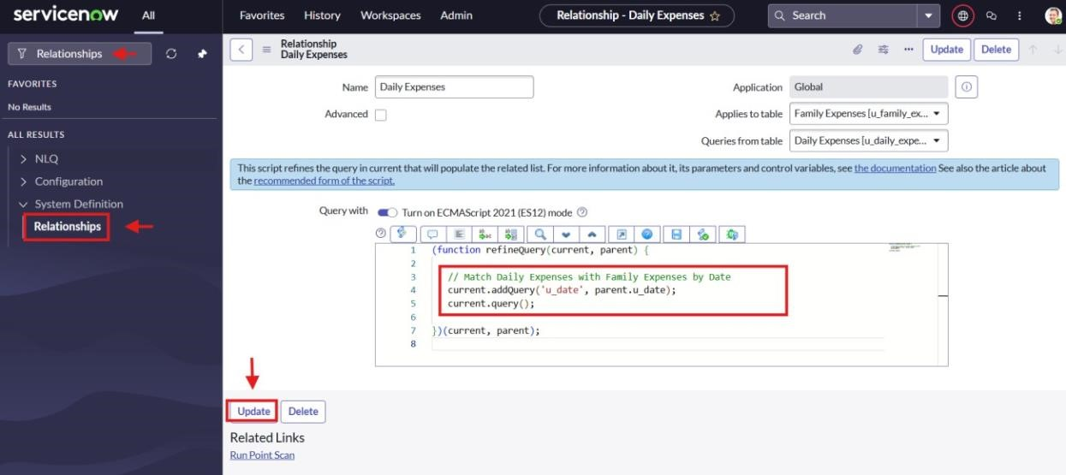

**Conclusion :**

The project **“Calculating Family Expenses using ServiceNow”** was completed successfully.

We created tables, fields, relationships, and business rules to record and calculate daily expenses. This system helps families keep all expense details in one place, check them easily, and avoid manual mistakes.

It makes tracking money simple and organized.

In the future, we can add reports and charts to see monthly and yearly expenses clearly.